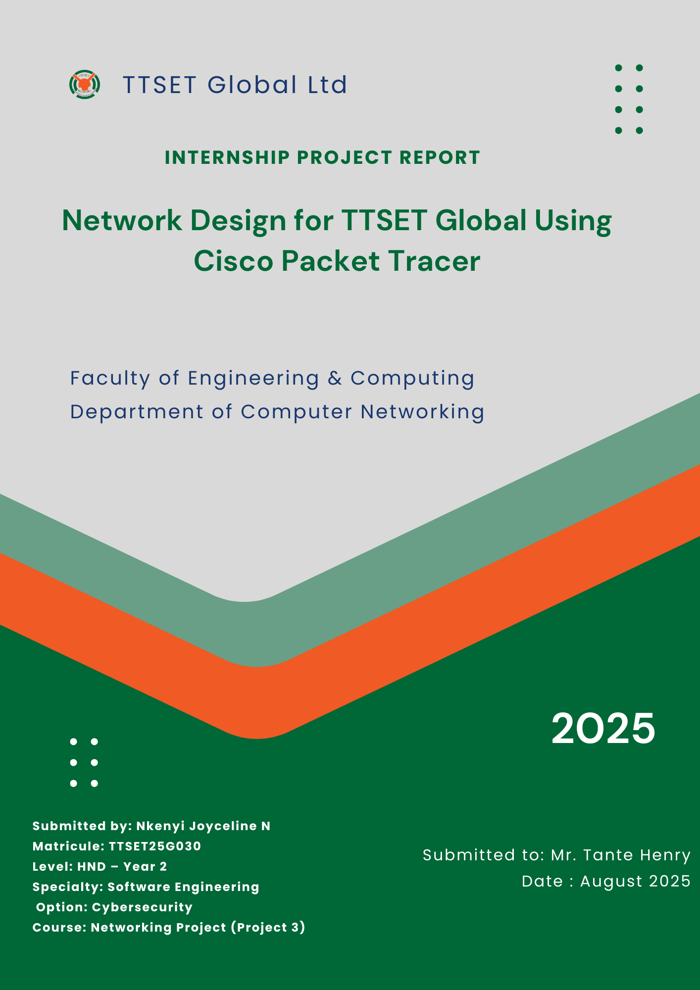
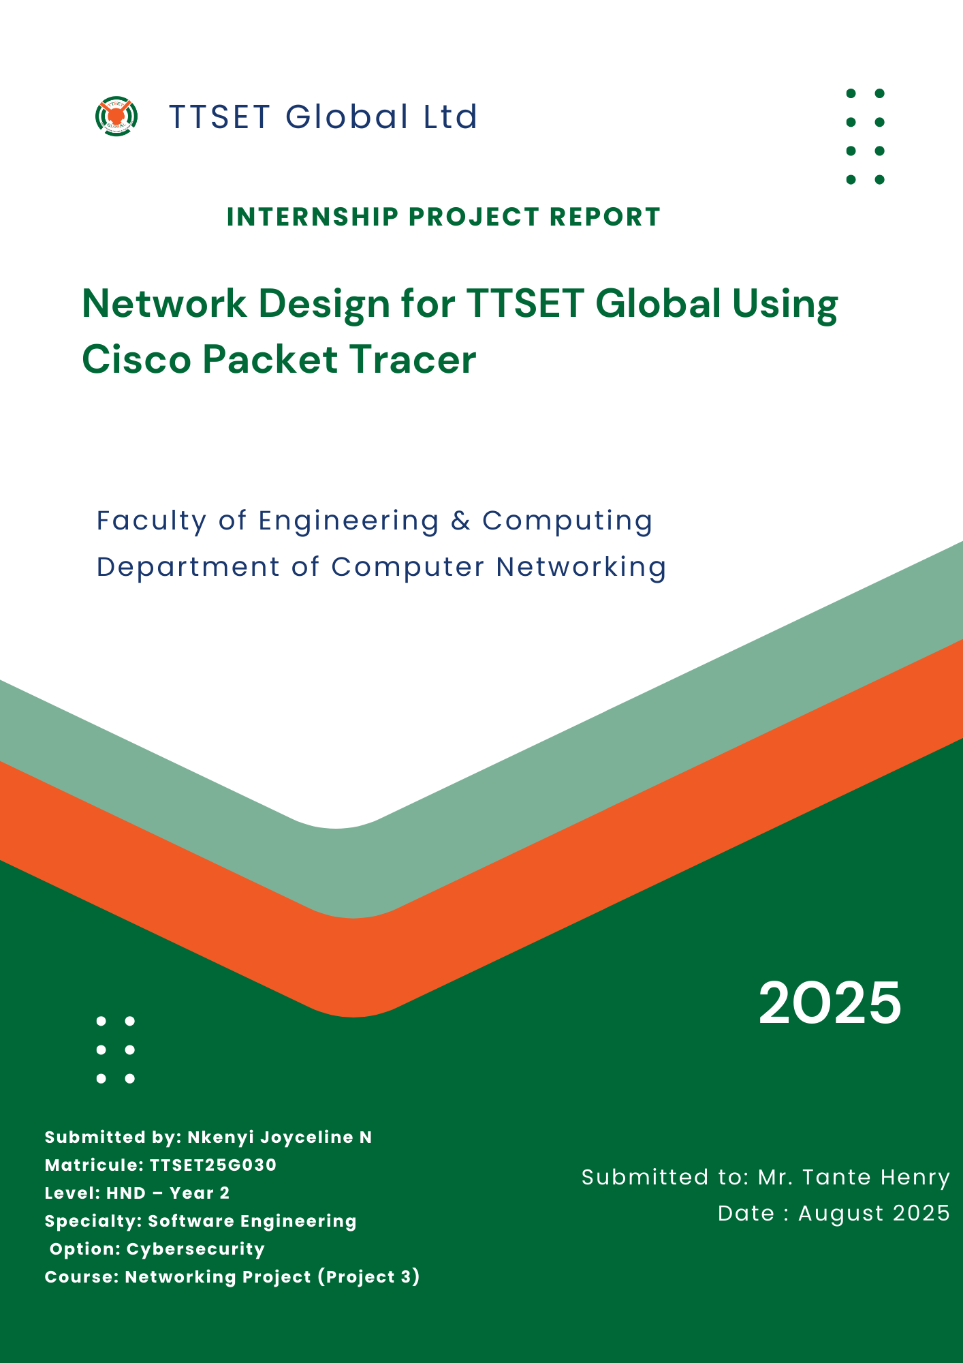
Network Design for TTSET Global University

I.1. Aim
The primary objective of this project is to design, implement, and evaluate a robust, scalable, and secure network infrastructure for TTSET Global University. The university comprises two campuses located 20 miles apart, housing multiple faculties and departments. The network must facilitate seamless communication, efficient resource sharing, and reliable internet access for administrative staff, faculty members, and students. Key goals include:

- Segmentation: Utilize VLANs to logically separate departments and faculties, enhancing security and traffic management.
- Routing: Implement RIPv2 for dynamic routing within the internal network and static routing for external server access.
- IP Address Management: Deploy DHCP services to automate IP address allocation, reducing administrative overhead.
- Centralized Services: Host essential services such as web, DNS, and DHCP servers within the IT department for centralized management.
- Scalability and Security: Design the network to accommodate future growth while incorporating security measures to protect against unauthorized access.

I.2. Principle (Process, Software Needed)
Process:
1. Requirement Analysis: Understand the university's organizational structure, departmental needs, and inter-campus communication requirements.
2. Network Design: Develop a logical and physical topology that addresses the identified requirements, incorporating VLANs, routing protocols, and IP addressing schemes.
3. Simulation: Utilize Cisco Packet Tracer to model the network, allowing for testing and validation before physical deployment.
4. Configuration: Set up routers, switches, VLANs, DHCP, and routing protocols as per the design specifications.
5. Testing and Evaluation: Verify network functionality, performance, and security through simulated scenarios and stress tests.
6. Documentation: Compile a comprehensive report detailing the design, implementation, and evaluation processes.

I.3. Network Diagram
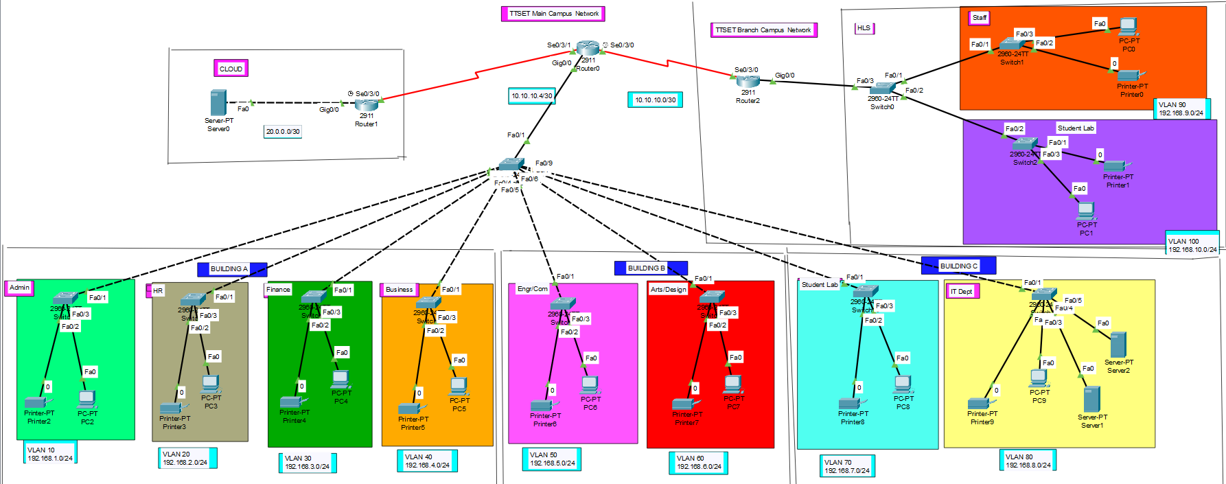

1.4. List of Materials
- Cisco Packet Tracer: A network simulation tool used for designing, configuring, and testing network topologies virtually.
- Router E (External Gateway Router)
Switches:
- Switch A (Building A)
- Switch B (Building B)
- Switch C (Building C)
- Switch D (Smaller Campus)
End Devices:
- PCs for administrative staff and faculty members
- PCs for student labs
Servers:
- Web Server
- DNS Server
- DHCP Server
- Cabling: Ethernet cables for device interconnections

Software:
  - Cisco Packet Tracer: For network simulation and configuration.

I.5. Network Configuration
1. VLAN Configuration
Each department was assigned a separate VLAN to enhance security and reduce broadcast traffic.
On Each Switch:
Switch> enable
Switch# configure terminal
Switch(config)# vlan [VLAN_ID]
Switch(config-vlan)# name [VLAN_NAME]
Switch(config-vlan)# exit

Example for VLAN 10 (Management):
plaintext
Switch(config)# vlan 10
Switch(config-vlan)# name Admin
Switch(config-vlan)# exit

2. Assigning VLANs to Ports:
Switch(config)# interface range fa0/2-3
Switch(config-if-range)# switchport mode access
Switch(config-if-range)# switchport access vlan 10
Switch(config-if-range)# exit
3. Configuring Trunk Ports:
Switch(config)# interface fa0/1
Switch(config-if)# switchport mode trunk
Switch(config-if)# exit

4. Router Configuration (Router-on-a-Stick)
On Router A (Main Campus Core Router):

Main Campus:
  - Building A:
- Administrative Departments: Management (VLAN 10), HR (VLAN 20), Finance (VLAN 30)
- Faculty of Business: VLAN 40
- Connectivity: Connected to the Core Router via Switch A

  - Building B:
- Faculty of Engineering and Computing: VLAN 50
- Faculty of Art and Design: VLAN 60
- Connectivity: Connected to the Core Router via Switch B

  - Building C:
- Student Labs: VLAN 70
- IT Department (Hosting Servers): VLAN 80
- Connectivity: Connected to the Core Router via Switch C

- Smaller Campus:
  - Faculty of Health and Sciences:
- Staff: VLAN 90
- Student Labs: VLAN 100
- Connectivity: Connected to the Main Campus Core Router via Router D
Interconnections:

- Core Router (Router A): Central device connecting all buildings and managing inter-VLAN routing.
- Router D: Connects the Smaller Campus to the Main Campus Core Router.
- Router E (External Gateway): Provides internet access and manages static routing to external servers.

5.Inter-VlAN Configuration
Router> enable
Router# configure terminal
Router(config)# interface gig0/0
Router(config-if)# no shutdown
Router(config-if)# exit

6.For Each VLAN:
Router(config)# interface gig0/0.[VLAN_ID]
Router(config-subif)# encapsulation dot1Q [VLAN_ID]
Router(config-subif)# ip address 192.168.[VLAN_ID].1 255.255.255.0
Router(config-subif)# exit

Example for VLAN 10:
Router(config)# interface gig0/0.10
Router(config-subif)# encapsulation dot1Q 10
Router(config-subif)# ip address 192.168.10.1 255.255.255.0
Router(config-subif)# exit
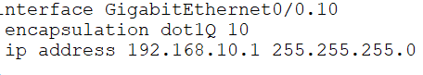

7. DHCP Configuration
Router-based DHCP was enabled in Building A to assign IP addresses dynamically to end devices.
On Router A:
Router(config)# ip dhcp pool Admin
Router(dhcp-config)# network 192.168.10.0 255.255.255.0
Router(dhcp-config)# default-router 192.168.10.1
Router(dhcp-config)# dns-server 192.168.10.1
Router(dhcp-config)# exit
Repeated for other VLANs as needed.
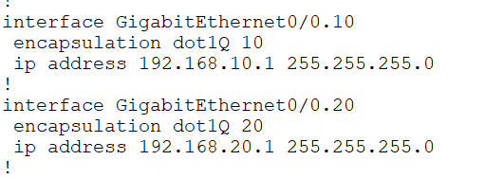

8. RIPv2 Configuration
On All Routers:
Router> enable
Router# configure terminal
Router(config)# router rip
Router(config-router)# version 2
Router(config-router)# no auto-summary
Router(config-router)# network 192.168.10.0
Router(config-router)# network 192.168.20.0
(Include all relevant networks)
Router(config-router)# exit
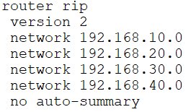

9. Static Routing (On Router E - External Gateway)
Router> enable
Router# configure terminal
Router(config)# ip route 0.0.0.0 0.0.0.0 [Next-Hop IP]
Router(config)# exit

10. Security Measures
  - Switch port security was enabled to limit MAC addresses.
  - Admin passwords were configured on all devices.
  - Telnet was disabled in favor of SSH for remote access.

I.6 Conclusion
This internship assignment provided practical experience in designing and implementing a scalable, secure, and functional network for a multi-building university environment. Using Cisco Packet Tracer, we successfully created a prototype that meets the network needs of TTSET Global, including VLAN segmentation, inter-campus routing with RIPv2, static routing for external server access, and secure IP address management via DHCP.

The design ensures:
  - Performance through reduced broadcast domains (VLANs),
  - Scalability by allowing additional faculties or users to be added,
  - Security via VLAN isolation, password protection, and limited access.
The project strengthens our understanding of real-world networking and prepares us for professional IT challenges.

